Pharmaceutical Chemistry 2012 9812
Higher 3
Mark Scheme

1 | (a) | (i) | (Least basic) Pyrrole < pyridine in nicotine < pyrrolidine in nicotine (most basic)  [1]  In pyrrole, the lone pair on N is used to complete the aromatic sextet hence not available to accept proton. The nitrogen in pyridine contributes 1 electron to complete the aromatic sextet and thus there is 1 lone pair which can accept a proton. [1]  The lone pair in sp³ N in N-methyl pyrrolidine (_{p}K_{a} = 10.96) is more available than the lone pair in sp² N in pyridine (_{p}K_{a} = 6.16). Hence, pyridine stronger base among the two.[1]
 |  | (ii) | Pyridine does not undergo Friedel-Craft Reaction.[1]  In acidic condition of the Friedel-Craft reaction, protonation on the N resulted in a positively charged intermediate that further reduces the tendency to be attacked by electrophiles. [1]  (Other electrophilic substitutions may still proceed with slow yield, but Fridel-Craft reaction does not occur at all.  Hence, the answer using just electronegativity of N is not acceptable.)
 |  | (iii) | Dissociation of one N-H bond leads to resonance-stabilised forms of anion, 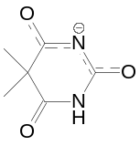[1] or 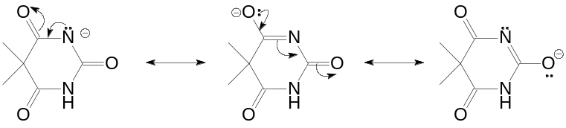  all three structures [1]
 |  | (iv) | pH = pK_{a} + log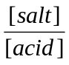 => 7.4 = 8.0 + log 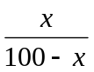  = 0.251 [1]  => x = 0.201 => Percentage of ionized form = 20.1% [1]
 | (b) | (i) | Stimulants acts on nerve synapses of central nervous system  (CNS) to “wake up” the CNS.  Stimulants increase the heart rate/breathing rate/blood pressure and brain function / elevates our mood, increases alertness and attention as well as psychomotor stimulation.  (List a few effects) [1]
 |  | (ii) | At least 2 points in each drug. [2]
  Caffeine | Nicotine
  Competitive antagonist to adenosine receptors. | Agonist to acetylcholine.
  Increasing amount of adrenaline and noradrenaline. | Increasing amount of adrenaline and other alkaloids.
  Inhibits an enzyme that breaks down cyclic-AMP. | Production of alkaloids inhibit monoamine oxidase enzymes that destroy dopamine.
 |  | (iii) | The tertiary amine in nicotine is protonated as it is an agonist to acetylcholine, and would have formed ionic bonding between its protonated amine and the receptor. [1] (or compare the relative basicity)  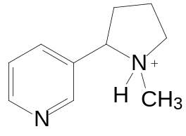[1]
 |  | (iv) | Hydrogen bonding between –OH group in ephedrine and –OH groups in receptor.[1]  Ionic bonding between protonated amine and carboxylate groups in receptor.[1]
 |  | (v) | Ephedrine is more lipophilic due to the lack of phenolic groups in the structure. Hence, it can pass through the blood brain barrier more effectively.[1]
 | (c) | (i) | Increase as new dose is absorbed; decrease due to metabolism of the drug. At steady state, the rate of dosing and elimination were equal. [1]
 |  | (ii) | Average concentration at steady state=1.98+0.99 / 2  = 1.49 μg/ml [1]  = (1.49 x 10⁻⁶ /189) x 1000 = 7.88 x 10⁻⁶ moldm⁻³ [1]
 |  | (iii) | Toxic level = 1.32x10⁻⁸ x 1000 = 1.32 x 10⁻⁵ moldm⁻³  TI = 1.32 x 10⁻⁵ / 7.88 x 10⁻⁶ = 1.68 [1]
[Total: 20m]

2 | (a) | (i) | Agonists compete for receptor site, causing the necessary change in shape of the receptor while antagonists block the site without causing the necessary change in shape.[2]
 |  | (ii) | Aromatic ring: Van-der Waals, [1]  hydrogen bonding using H of N-H bond in the indole ring, [1]  ionic interaction at the amine groups (which are protonated at physiological pH)[1]
 |  | (iii) | Advantage: rapid delivery[1]
 | (b) | (i) | Non-narcotic analgesic. [1]  The drug inhibits cyclo-oxygenase that stop the cell to produce prostaglandins. [1]
 |  | (ii) | Dichlofenac as it is the only compound containing isotopes in the structure. [1]  Cl-35 and Cl-37 isotopes exist in a ratio of 1 : 3  Presence of 2 Cl atoms in the same fragment ions account for the ratio  ³⁵Cl, ³⁵Cl : ³⁵Cl, ³⁷Cl : ³⁷Cl, ³⁷Cl  0.75 x 0.75 2(0.25 x 0.75) 0.25 x 0.25 [1]  9 : 6 : 1  Mass spectrum 9: 6 : 1 [1]  (using ³⁵Cl) M = 295 [M-H₂O]⁺ = 295-18 = 277  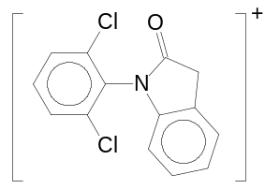[1]
 |  | (iii) | 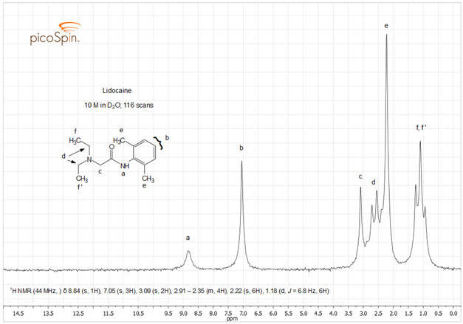
  δ | Reason
  8.84 (a) | Labile H on N of amide.
  7.05 (b) | 3 Aromatic H
  3.09 (c) | CH₂ with no adjacent H but near electronegative atom
  2.91-2.38 (d) | CH₂ adjacent to CH₃
  2.22 (e) | CH₃ on aromatic ring
  1.18 (f) | CH₃ adjacent to CH₂
Lidocaine [1]
1 mark for 2 Correctly assigned protons [3]
1 mark for 2 correct reasons. [2]

 |  | (iv) | In the presence of D₂O, the D is able to exchange with the H in –OH in the following equation.  ROH + D₂O ⬄ ROD + HDO  Since deuterium does not resonate within the applied field, it leads to disappearance of peak. [1]  -COOH in dichlofenac, mefenamic acid, naproxen  -CONH- in lidocaine  -NH in dichlofenic and mefenamic acid [1]
 |  |  | [Total: 20m]

3 | (a) | (i) | I: concentrated H₂SO₄, heat under reflux [1]  II: KMnO₄ or H₂O₂ [1]
 |  | (ii) | When the electrophile attacks at the ortho position, the positive charge can be delocalized over the 4 atoms in the ring:  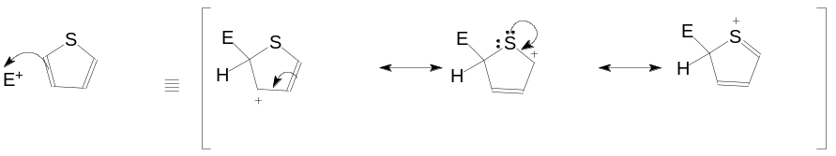[1]  When the electrophile attacks at the meta position, there are less resonates:  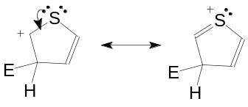 [1]
 |  | (iii) | Reduction[1]  LiAlH₄ in dry ether or NaBH₄ in aqueous methanol [1]
 |  | (iv) | 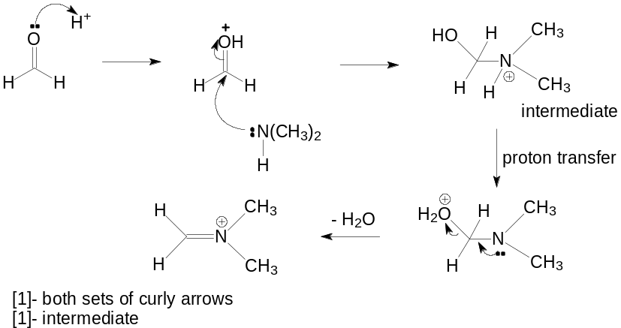
 |  |  | 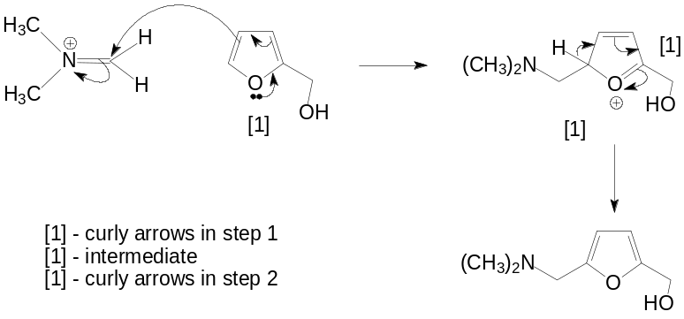
 |  | (v) | 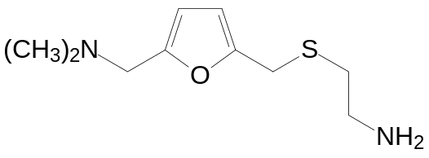  Compound C [1]
 |  | (vi) | NO₂- is an EWG that can stabilize the negative charge on the C as shown below during the formation of intermediate. [1]  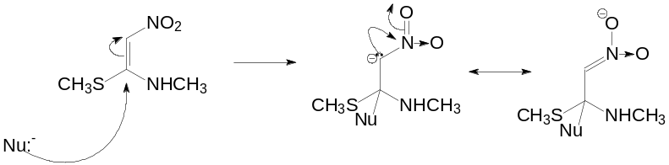  [1]-resonance structures
 | (b) | (i) | Spectrum A belongs to pyridine and B belongs to quinoline. [1]
 |  |  | There is higher degree of conjugation in quinoline for delocalisation of electrons that causes the energy gap to decrease thus shifting the absorption to higher wavelength.[1]
 |  | (ii) | Beer Lambert’s Law is the linear relationship between the absorbance and concentration of the absorbing species. [1]  Since no absorption occurs for pyridine at 290 nm, absorption was purely due to quinoline.  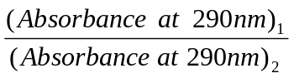= 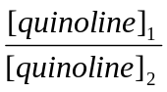  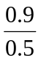 = 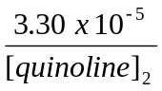  [quinoline] = 1.83 x 10⁻⁵ mol dm⁻³ [1]
For quinoline (at 250 nm)

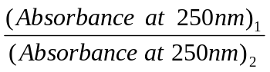=
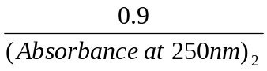= 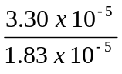
Absorbance at 250 nm for quinoline = 0.499
Absorbance at 250 for pyridine = 0.92 - 0.499 = 0.421 [1]

= 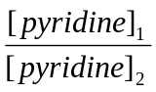

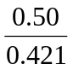 = 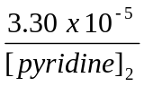

[pyridine] = 2.78 x 10⁻⁵ mol dm⁻³ [1]

4 | (a) | (i) | 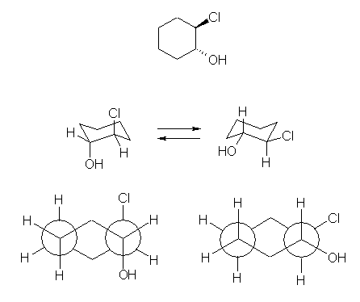  Conformation 1[1] Conformation 2 [1]  (2) has a lower energy because the bulky groups are away from each other in the equatorial position. [1]
 |  | (ii) | Diastereomers [1]  1) Add an optically active carboxylic acid to the racemic mixture.  2) Carry out a fractional distillation of the 2 diasteromer esters due to differ boiling points. [1]  3) Hydrolyse the esters using dil H₂SO₄ / heat.  (Basic conditions might result to hydrolysis of alkyl chloride in the isomers.)
 |  | (iii) | Nucleophilic Substitution (S_{N}2)[1]  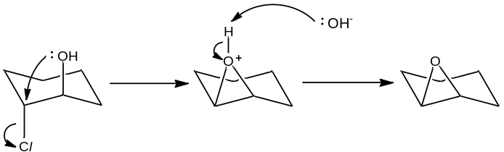[1]  Elimination (E2)[1]  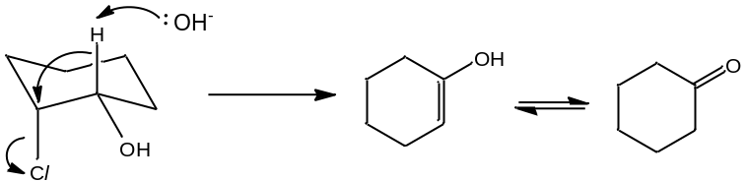[1]
 | (b) | (i) | Possible toxicity of unwanted isomers; [1]  agonist/antagonist activity of unwanted isomer which might interfere/distort the pharmacological effect of the desired isomer; [1]  even if the other isomer is not toxic or have any physiological effect, presence of only half of the dose containing the active isomer may not produce a therapeutic effect.[1]
 |  | (ii) | 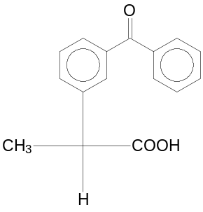[1]
 |  | (iii) | It fits the active site of the enzyme, forms a covalent bond. This reaction is irreversible such that the enzyme is out of action. | [1]
 |  | (iv) | Inactive T compare to the rest suggest importance of aromatic moiety that forms van der Waals forces.[1]  U, ketoprofen suggested presence of bulky groups reducing effectiveness of R groups forming van der Waals forces.[1]  V and ketoprofen suggested a replacement of C to electronegative S atom increase effectiveness of attraction maybe through dipole-dipole attraction. [1]
 |  | (v) | Difference in the 3D spatial arrangement of the atoms at the chiral carbon may prevent the R isomer from binding effectively at the receptor site. | [1]
 |  | (vi) | Esterification of the polar carboxylic acid group – makes it lipophilic [1]  Ethanol, conc H₂SO₄ catalyst[1]
 |  |  | [Total: 20]

5 | (a) | N in bond A is sp² hybridised (or lone pair on N is delocalized into the carbonyl group). Hence, the C–N bond shows double bond character.  Due to ring strain arising from the four membered ring, N in bond B is sp³ hybridised. Hence, the bond is longer.  Correct comparison of the difference [1]  Ring strain [1]  Lone pair of electrons on the nitrogen atom in amide is delocalised into the carbonyl group, hence reducing electron deficiency of the carbonyl C atom to a greater extent. [1]  Thus, amide is less prone to nucleophilic attack than lactam. [1]
 | (b) | (i) | 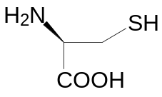 Cys[1] 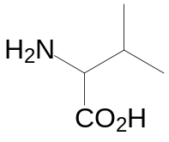Valine [1]
 |  | (ii) | 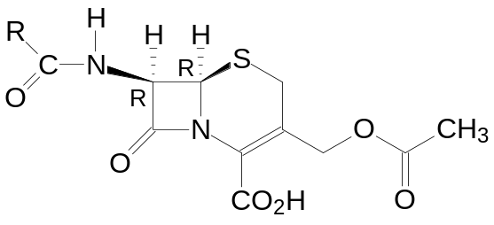[1]
 |  | (iii) | carboxylic acid, sulphide, alkene [2]
 |  | (iv) | It prevents the cross linking of the 10-aminoacids units on adjacent chains during the final stage of cell wall formation. [1]
 |  | (v) | Between 0.132 – 0.147 nm. [1]  There is greater extent of delocalization of lone pair on N in cephalosporin due to less ring strain created from 6 membered ring compared to penicillin.[1]
 |  | (vi) | 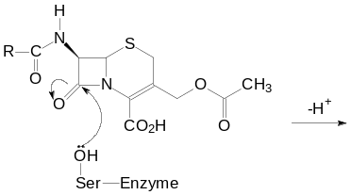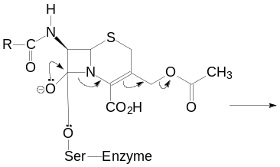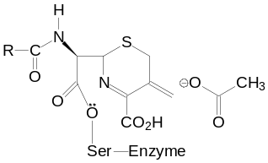  Attack of serine on electron deficient carbon/  opening of β-lactam ring [1]  Flow of electrons [1]  Structure of final product [1]
 |  | (vii) | OH⁻ is a poor leaving group.[1]

 | (c) | (i) | Diffuse into the cell membrane and cause ions leakage.[1]  The hydrophobic carbon chain suggested the interaction of this part with the hydrophobic tails of the cell membrane. [1]  It will create a hydrophilic part of the chain containing –OH groups form the hydrophilic channel/pore that provides the path to leak ions out the cell. [1]
 |  | (ii) | Disruption of the synthesis of folic acid [1]  Or Disruption of protein synthesis  Or Disruption of nucleic acid transcription
 |  |  | [Total:20]

6 | (a) | (i) | Formation of B from A:  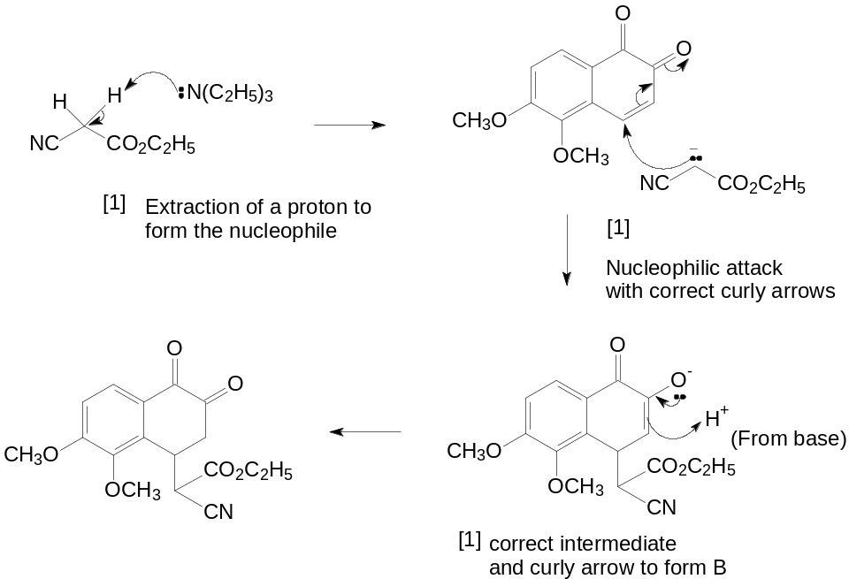
Formation of D from C:

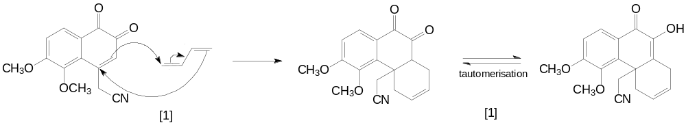
 |  | (ii) | Type of reaction: reduction (of amide) [1]
 |  | (iii) | Any two [1] x 2  (1)Only 1 of the 5 rings in morphine skeleton is needed but a hydrophobic right hand side of the molecule aids activity.  (2) the aromatic ring is essential  (3) the phenolic –OH is not essential, but helps  (4) the basic nitrogen atom is essential
 | (b) | (i) | Separation is based on partition and adsorption of solutes between 2 immiscible phases.  The stationary phase which is non-polar is silica attached to hydrocarbon chain. The mobile phase which is polar is usually mixture of water and methanol.  The polar molecules will interact more strongly with the polar solvent molecules as compare d to the stationary non polar phase and will have shorter retention time | [3]
 |  | (ii) | The 3 compounds have different polarity, thus they will absorb the stationary phase to different extent and elute at different speeds; have different retention times.  Increasing retention times, morphine, 6-acetylmorphine, heroine.  Since all the 3 compounds are rather polar, they will be adsorbed on the stationary polar phase and experience difficulty in eluting out if normal phase is used. | [3]
 |  | (iii) | The 3 compounds are non-volatile and since high temperature is required to vaporise them, and are likely to decompose and cannot be analysed. | [2]
 |  | (iv) | UV spectroscopy. All the compounds contain conjugated system and will absorb in the UV region. | [2]
 |  | (v) | Concentration ratio = ½ (6 x 2): ½ (13 x 2): ½ (3x 7) = 12: 26: 21 | [2]

END OF PAPER

